



Contents
Overview 1
Lesson: Introduction to Operations Master Roles 2
Lesson: Transferring and Seizing
Operations Master Roles 10
Lesson: Planning the Placement of
Operations Masters 23
Lab A: Managing Operations Masters 35
Course Evaluation 38

Module 9: Managing Operations Masters

Information in this document, including URL and other Internet Web site references, is subject to change without notice. Unless otherwise noted, the example companies, organizations, products, domain names, e-mail addresses, logos, people, places, and events depicted herein are fictitious, and no association with any real company, organization, product, domain name, e-mail address, logo, person, place or event is intended or should be inferred. Complying with all applicable copyright laws is the responsibility of the user. Without limiting the rights under copyright, no part of this document may be reproduced, stored in or introduced into a retrieval system, or transmitted in any form or by any means (electronic, mechanical, photocopying, recording, or otherwise), or for any purpose, without the express written permission of Microsoft Corporation.

Microsoft may have patents, patent applications, trademarks, copyrights, or other intellectual property rights covering subject matter in this document. Except as expressly provided in any written license agreement from Microsoft, the furnishing of this document does not give you any license to these patents, trademarks, copyrights, or other intellectual property.

© 2003 Microsoft Corporation. All rights reserved.

Microsoft, MS-DOS, Windows, Windows NT, Active Directory, Active X, MSDN, PowerPoint, Visio, Visual Basic, Visual C++, and Windows Media are either registered trademarks or trademarks of Microsoft Corporation in the United States and/or other countries.

The names of actual companies and products mentioned herein may be the trademarks of their respective owners.

Overview
INCLUDEPICTURE "../Modules/PowerPnt/2279B_09/Slide_306.jpg" \* MERGEFORMATINET 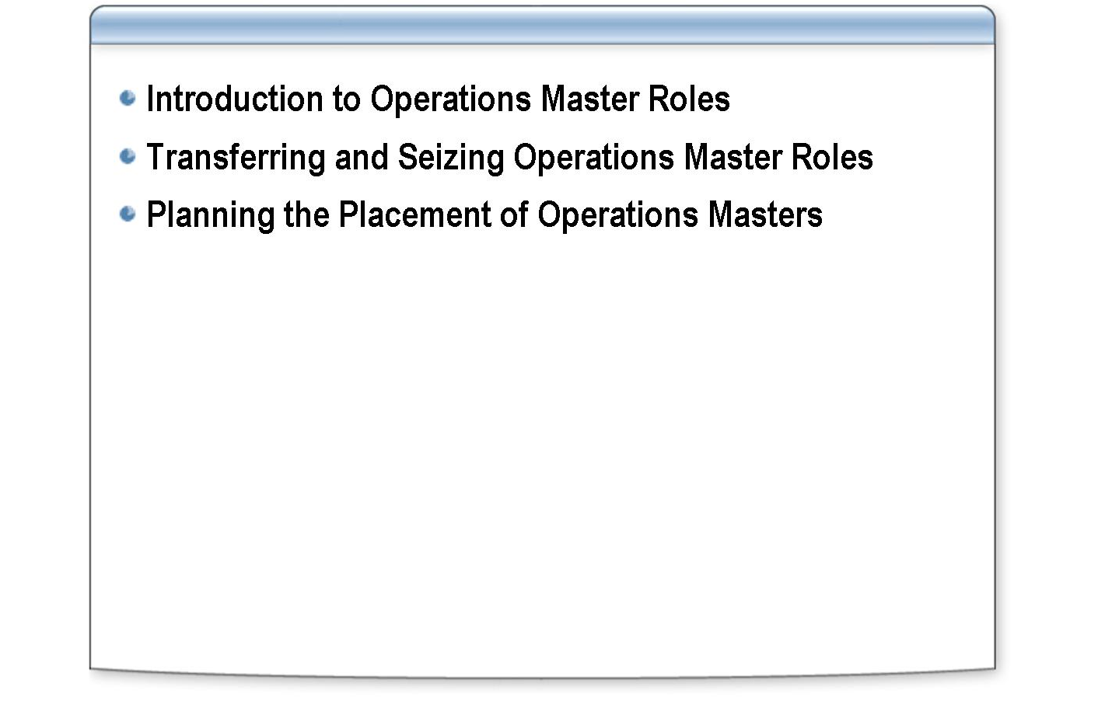
*****************************illegal for non-trainer use******************************
An operations master is a domain controller that performs a specific role in the Active Directory® directory service. Knowing the specific operations master roles of each domain controller in an Active Directory network can help you replicate data and use network bandwidth efficiently. This module describes the operations master roles, how to transfer and seize operations master roles, and how to plan for placing operations masters.
Introduction
After completing this module, you will be able to:
Objectives
- Explain the purpose of the five operations master roles in Active Directory.
- Transfer and seize operations master roles in Active Directory.
- Plan for placing operations masters in Active Directory.

Lesson: Introduction to Operations Master Roles

INCLUDEPICTURE "../Modules/PowerPnt/2279B_09/Slide_369.jpg" \* MERGEFORMATINET 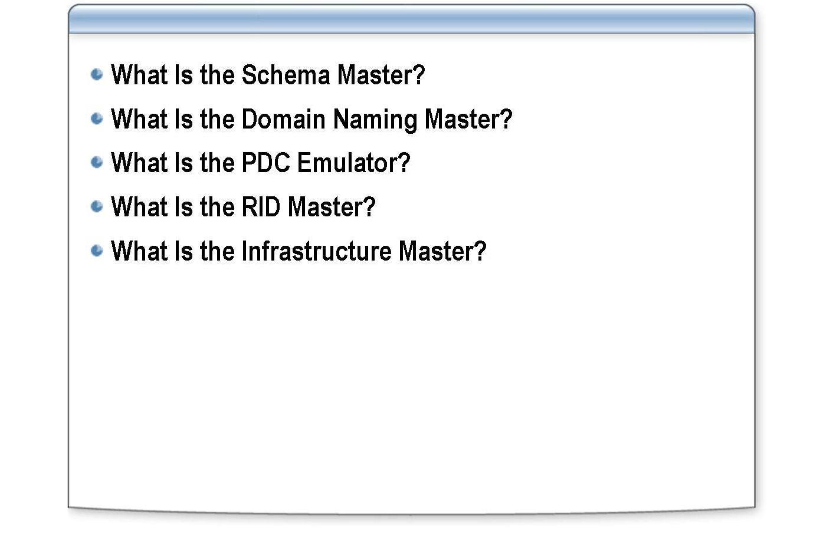
*****************************illegal for non-trainer use******************************
Active Directory defines five operations master roles: the schema master, domain naming master, primary domain controller (PDC) emulator, relative identifier (RID) master, and the infrastructure master. This lesson explains the purpose of each operations master role.
Introduction
After completing this lesson, you will be able to:
Lesson objectives
- Explain the purpose of a schema master.
- Explain the purpose of a domain naming master.
- Explain the purpose of a PDC emulator.
- Explain the purpose of a RID master.
- Explain the purpose of an infrastructure master.

What Is the Schema Master?

INCLUDEPICTURE "../Modules/PowerPnt/2279B_09/Slide_422.jpg" \* MERGEFORMATINET 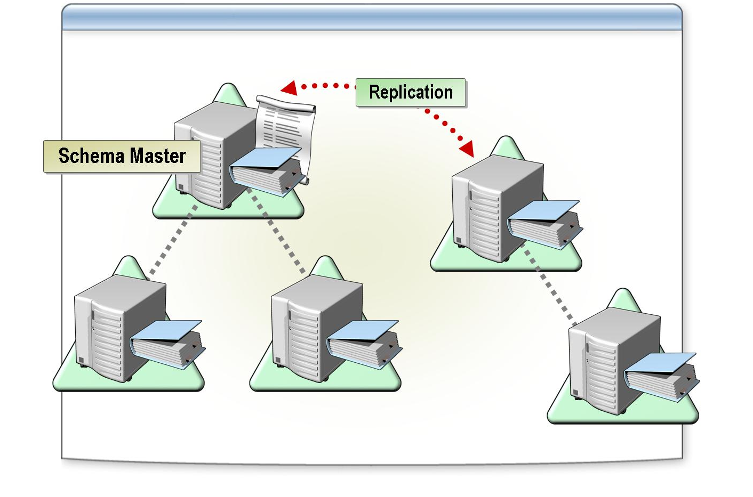
*****************************illegal for non-trainer use******************************
An Active Directory schema defines the kinds of objects—and the types of information about those objects—that you can store in Active Directory. Active Directory stores these definitions as objects. Active Directory manages the schema objects by using the object management operations that its uses to manage other objects in the directory.
Introduction
The schema master performs the following roles:
Roles performed by the schema master
- Controls all originating updates to the schema
- Contains the master list of object classes and attributes that are used to create all Active Directory objects
- Replicates updates to the Active Directory schema to all domain controllers in the forest by using standard replication of the schema partition
- Allows only the members of the Schema Admins group to modify the schema

Each forest has only one schema master. This prevents any conflicts that would result if two or more domain controllers attempt to simultaneously update the schema. If the schema master is not available, you cannot modify the schema or install applications that modify the schema.

What Is the Domain Naming Master?

INCLUDEPICTURE "../Modules/PowerPnt/2279B_09/Slide_424.jpg" \* MERGEFORMATINET 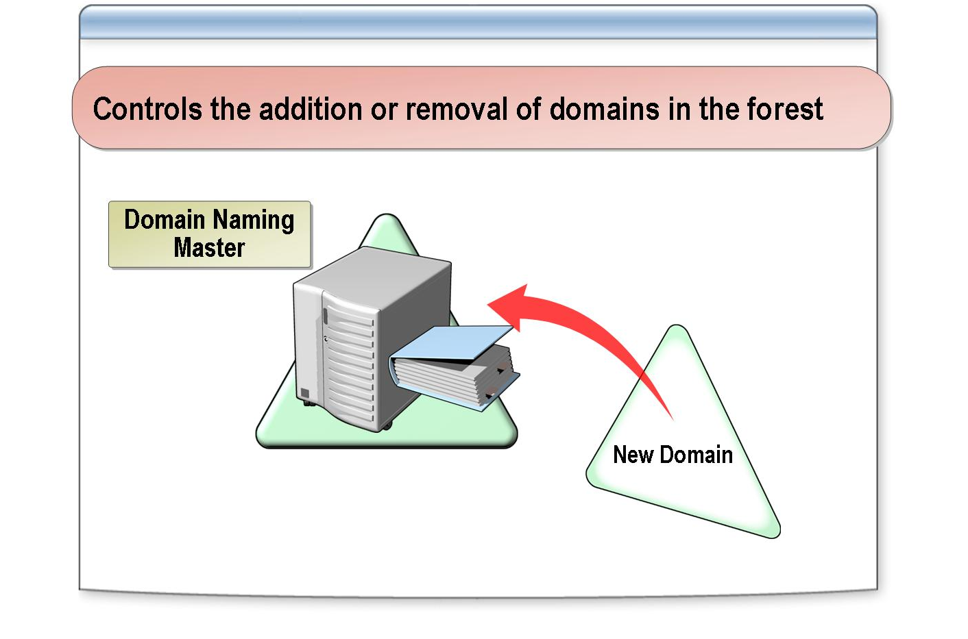
*****************************illegal for non-trainer use******************************
When you add or remove a domain from a forest, the change is recorded in Active Directory.
Introduction
The domain naming master controls the addition or removal of domains in the forest. There is only one domain naming master in each forest.
Roles performed by the domain naming master
When you add a new domain to the forest, only the domain controller that holds the domain naming master role can add the new domain. The domain naming master prevents multiple domains with the same domain name from joining the forest. When you use the Active Directory Installation Wizard to create a child domain, it contacts the domain naming master and requests the addition or deletion. If the domain naming master is unavailable, you cannot add or remove domains.

What Is the PDC Emulator?

INCLUDEPICTURE "../Modules/PowerPnt/2279B_09/Slide_425.jpg" \* MERGEFORMATINET 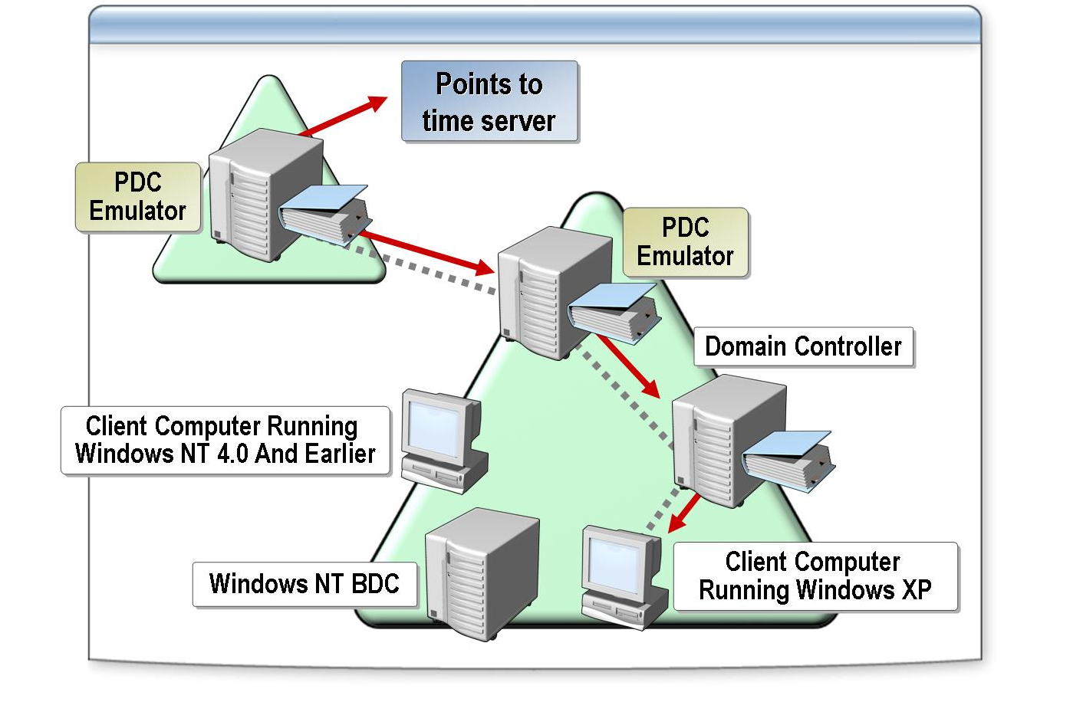
*****************************illegal for non-trainer use******************************
The PDC emulator acts as a Microsoft® Windows NT® primary domain controller (PDC) to support any backup domain controllers (BDCs) running Windows NT in a mixed-mode domain. When you create a domain, Active Directory assigns the PDC emulator role to the first domain controller in the new domain.
Introduction
The PDC emulator performs the following roles:
Roles performed by the PDC emulator
- Acts as the PDC for any existing BDCs. If a domain contains any BDCs or client computers running Windows NT 4.0 and earlier, the PDC emulator functions as a Windows NT PDC. The PDC emulator replicates directory changes to any BDCs running Windows NT.
- Manages password changes from computers running Windows NT, Microsoft Windows® 95, or Windows 98. Active Directory writes password changes directly to the PDC emulator.
- Minimizes replication latency for password changes. The time that is required for a domain controller to receive a change that was made on another domain controller is called replication latency. When the password of a client computer running Windows 2000 or later is changed on a domain controller, the domain controller immediately forwards the change to the PDC emulator. If a logon authentication fails at another domain controller because of a bad password, that domain controller will forward the authentication request to the PDC emulator before it rejects the logon attempt.
- Synchronizes the time on all domain controllers throughout the domain to its time. The Kerberos version 5 authentication protocol requires the time on domain controllers to be synchronized to enable authentication. Client computers in a domain also synchronize their time with the domain controller that authenticates the user.

- Prevents the possibility of overwriting Group Policy objects (GPOs). By default, Group Policy reduces the potential for replication conflicts by running on the domain controller that holds the PDC emulator role for that domain.

For more information about managing time synchronization, see “What Is the PDC Emulator?” in Module 9 on the Appendices page on the Student Materials compact disc.
Note

What Is the RID Master?

INCLUDEPICTURE "../Modules/PowerPnt/2279B_09/Slide_426.jpg" \* MERGEFORMATINET 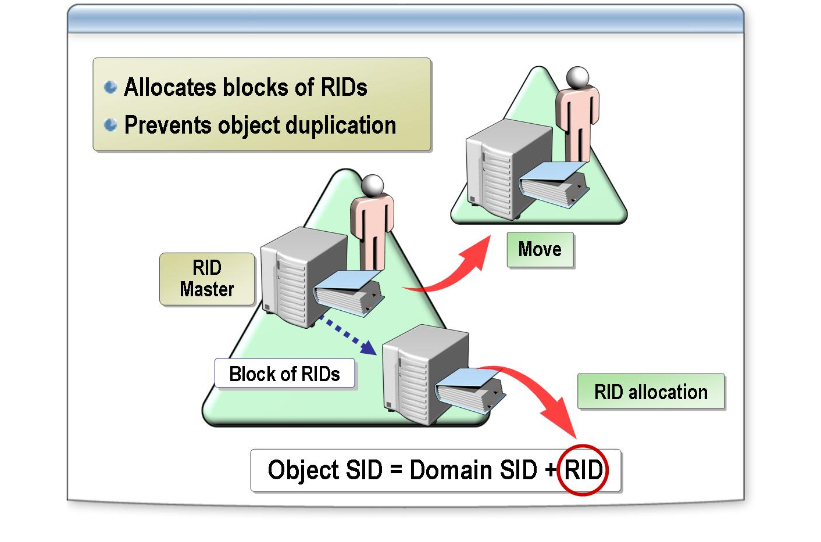
*****************************illegal for non-trainer use******************************
The relative ID (RID) master is a domain controller that allocates blocks of RIDs to each domain controller in the domain. Whenever a domain controller creates a new security principal, such as a user, group, or computer object, it assigns the object a unique security identifier (SID). This SID consists of a domain SID, which is the same for each security principal that is created in the domain, and a RID, which is unique for each security principal in the domain.
Introduction
The RID master supports creating and moving objects as follows:
How the RID master supports creating and moving objects
- Creating objects. To allow a multimaster operation to create objects on any domain controller, the RID master allocates a block of RIDs to a domain controller. When a domain controller requires an additional block of RIDs, it contacts the RID master, which allocates a new block of RIDs to the domain controller, which in turn assigns them to the new objects.
If a domain controller’s RID pool is empty, and the RID master is unavailable, you cannot create new security principals on that domain controller. You can view the RID pool allocation by using the Domain Controller Diagnostic utility (the dcdiag command).

You can install the Dcdiag utility by installing the support tools, which are located in the \Support\Tools folder on the product compact disc.
Note

- Moving objects. When you move an object between domains, the move is initiated on the RID master that contains the object. This way, there is no duplication of objects.
If you moved an object, but no single master kept this information, you could move the object to multiple domains without realizing that a previous move had already occurred.

The RID master deletes the object from the domain when the object is moved from that domain to another domain.

What Is the Infrastructure Master?

INCLUDEPICTURE "../Modules/PowerPnt/2279B_09/Slide_423.jpg" \* MERGEFORMATINET 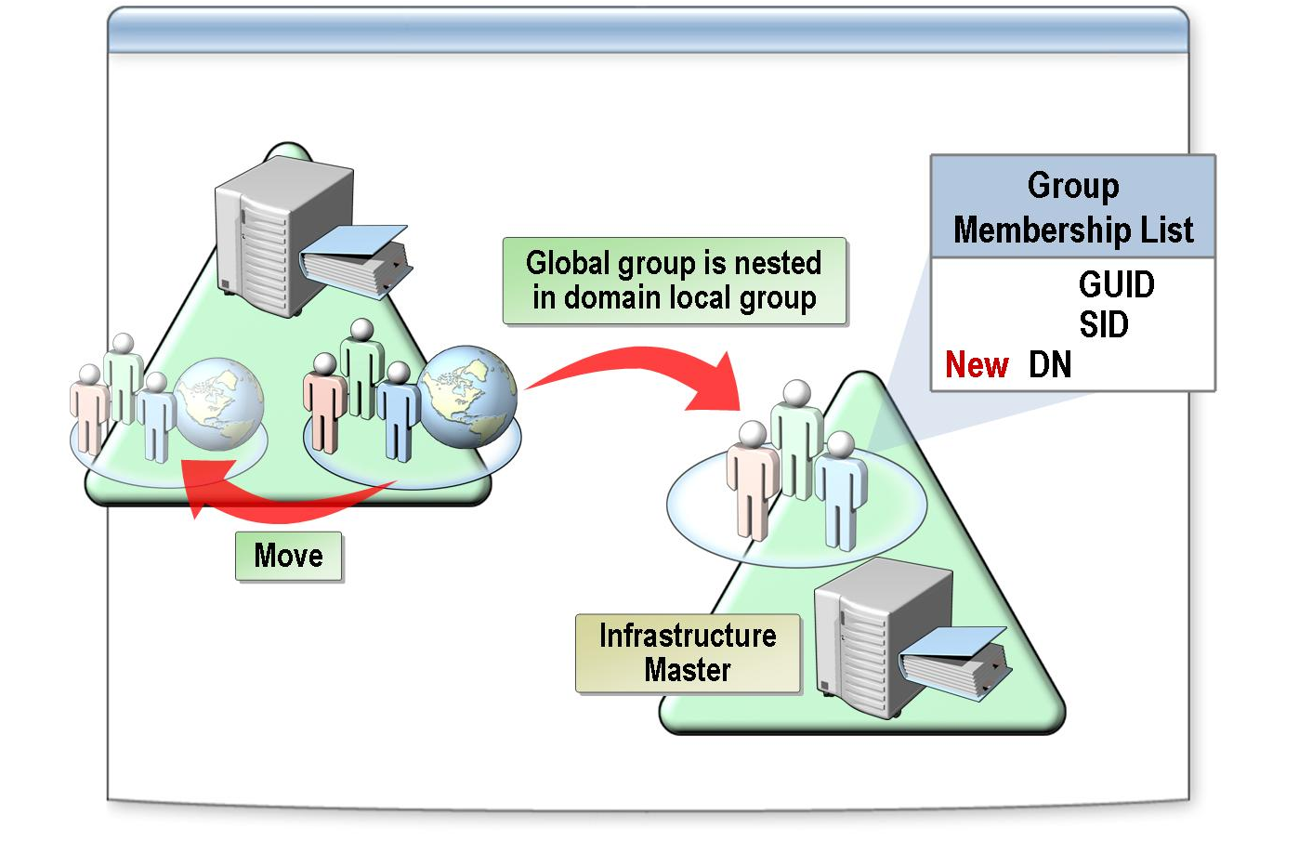
*****************************illegal for non-trainer use******************************
The infrastructure master is a domain controller that updates object references in its domain that point to objects in another domain. The object reference contains the object’s globally unique identifier (GUID), the distinguished name, and possibly a SID. Active Directory periodically updates the distinguished name and the SID to reflect changes that were made to the object, such as when you move an object within a domain or between domains or delete the object.
Introduction
If the SID or the distinguished name of a user account or group is modified in another domain, Active Directory must update the group membership for a group on your domain that refers to the changed user or group. The infrastructure master for the domain in which the group (or reference) resides updates the group membership by replicating the change throughout the domain.
Group membership identification
The infrastructure master updates object identification according to the following rules:
- If the object is moved, its distinguished name changes because the distinguished name represents its exact location in the directory.
- If the object is moved within the domain, its SID remains the same.
- If the object is moved to another domain, the SID changes to incorporate the new domain SID.
- The GUID does not change regardless of location because the GUID is unique across domains.

In a single domain forest, there is no requirement for the infrastructure master to function because there are no external object references for it to update.
Note

Do not make a domain controller that hosts the global catalog an infrastructure master. If the infrastructure master and the global catalog are on the same computer, the infrastructure master does not function because it does not contain any references to objects that it does not hold.

Infrastructure master and the global catalog
Periodically, the infrastructure master for a domain examines the references in its replica of the directory data to objects that are not held on that domain controller. It queries a global catalog server for current information about the distinguished name and the SID of each referenced object. If this information has changed, the infrastructure master makes the change in its local replica. It then replicates these changes to the other domain controllers within the domain.

Lesson: Transferring and Seizing Operations Master Roles

INCLUDEPICTURE "../Modules/PowerPnt/2279B_09/Slide_406.jpg" \* MERGEFORMATINET 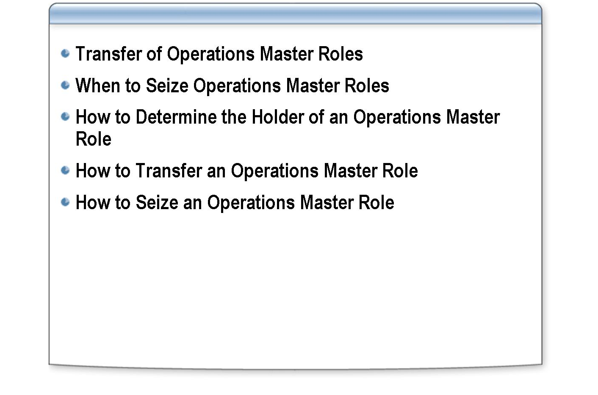
*****************************illegal for non-trainer use******************************
This lesson discusses the transfer and seizing of operations master roles. It explains how to determine the holder of an operations master role and how to transfer and seize an operations master role.
Introduction
After completing this lesson, you will be able to:
Lesson objectives
- Explain the purpose of transferring an operations master role.
- Explain the purpose of seizing an operations master role.
- Determine the holder of an operations master role.
- Transfer an operations master role.
- Seize an operations master role.

Transfer of Operations Master Roles

INCLUDEPICTURE "../Modules/PowerPnt/2279B_09/Slide_428.jpg" \* MERGEFORMATINET 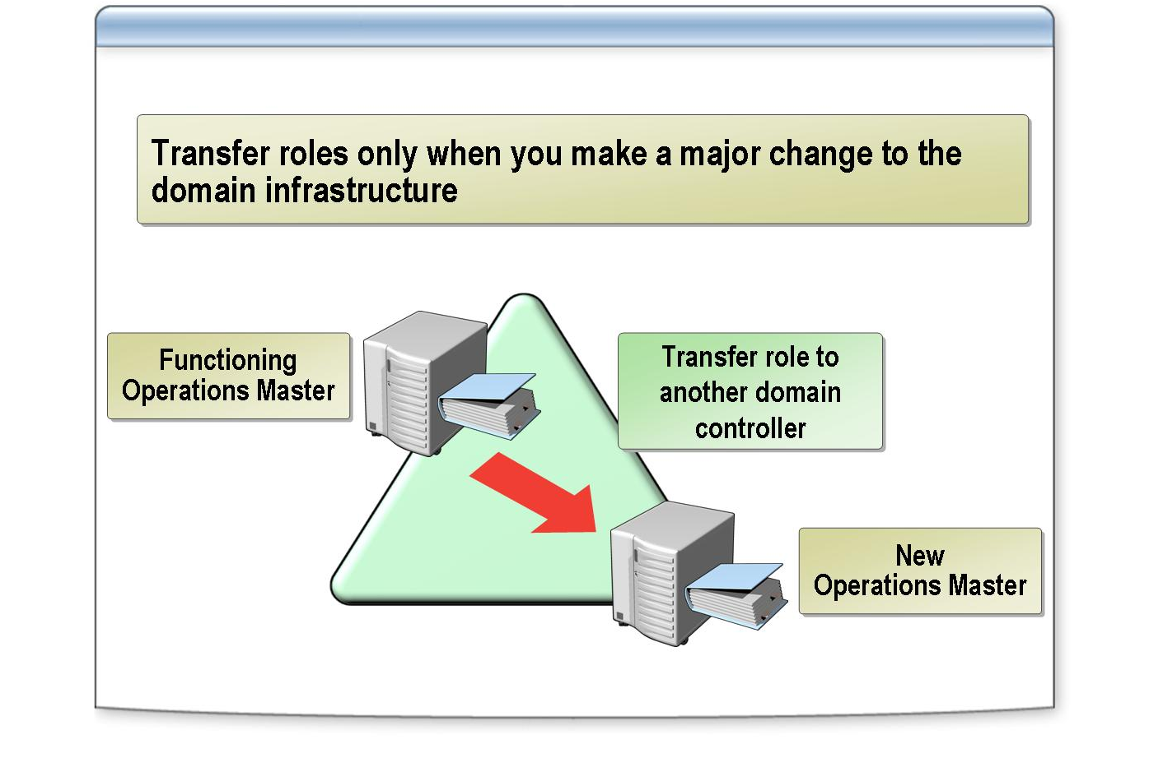
*****************************illegal for non-trainer use******************************
You place operations master roles in a forest when you implement the forest and domain structure. Transfer an operations master role only when you make a major change to the domain infrastructure. Such changes include decommissioning a domain controller that holds a role and adding a new domain controller that is better suited to hold a specific role. Transferring an operations master role means moving it from one functioning domain controller to another. To transfer roles, both domain controllers must be up and running and connected to the network.
Introduction
No data loss occurs when you transfer an operations master role. Active Directory replicates the current operations master directory to the new domain controller, which ensures that the new operations master has the most current information. This transfer uses the directory replication mechanism.
Implications of transferring a role
You must have the appropriate permissions to transfer an operations master role. The following table lists the groups that you must be a member of to transfer an operations master role.

Required permissions
Operations master | Authorized group
Schema master | The Change Schema Master permission is granted by default to the Schema Admins group.
Domain naming master | The Change Domain Master permission is granted by default to the Enterprise Admins group.
PDC emulator | The Change PDC permission is granted by default to the Domain Admins group.
RID master | The Change RID Master permission is granted by default to the Domain Admins group.
Infrastructure master | The Change Infrastructure Master permission is granted by default to the Domain Admins group.

When a domain controller is demoted to a member server, it relinquishes any operations master roles that it held to other domain controllers arbitrarily. To control which domain controllers get the role, transfer the roles prior to demotion.
Note

When to Seize Operations Master Roles

INCLUDEPICTURE "../Modules/PowerPnt/2279B_09/Slide_447.jpg" \* MERGEFORMATINET 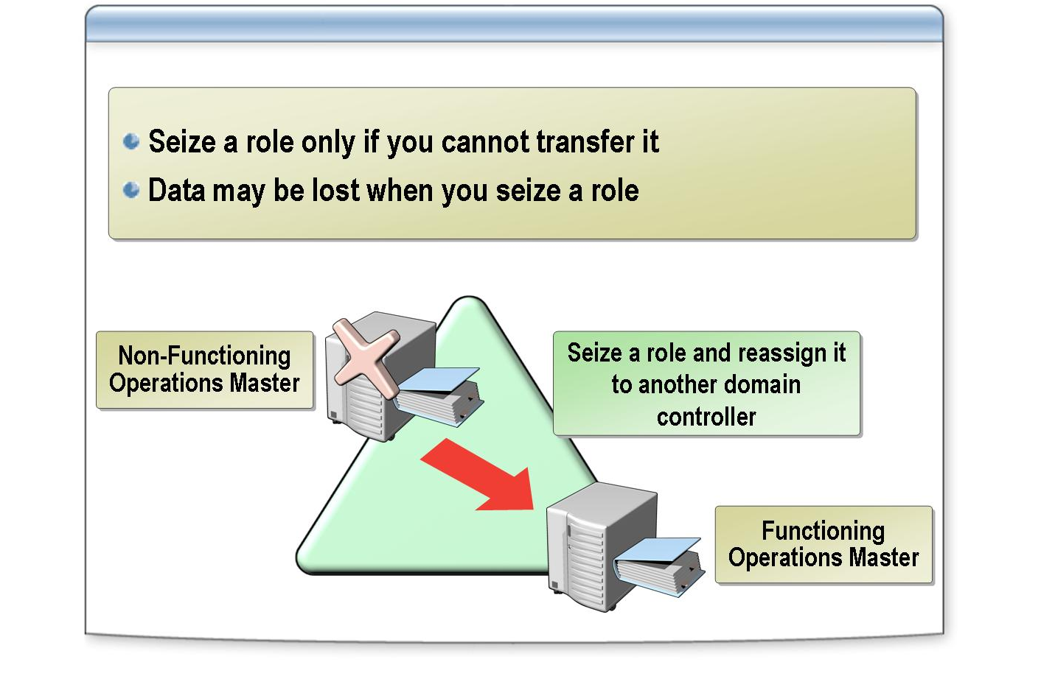
*****************************illegal for non-trainer use******************************
Seizing an operations master role means forcing an operations master role on another domain controller, which cannot contact the failed domain controller when you seize the role. You must be a member of an authorized group to seize a role.
Introduction
Seizing an operations master role is a drastic step. Do it only if the current operations master will never be available again and if you cannot transfer the role. Because the previous role holder is unavailable during a seizure, you cannot reconfigure or inform it that another domain controller now hosts the operations master role.
Implications of seizing a role
To reduce risk, perform a role seizure only if the failed operations master role affects the performance of Active Directory in an unacceptable way. Calculate the effect by comparing the impact of the operations master role being unavailable to the amount of work that you must perform to bring the previous role holder safely back online after you seize the role.

Before you seize a role, you must permanently disconnect the domain controller that holds the operations master role from the network.
Important

If you do manage to repair the previous role holder and bring it back online after you seize an operations master role, the previous role holder waits until after a full replication cycle before it resumes the role of operations master. This way, it can determine if another operations master exists before it comes back online. If it detects one, it reconfigures itself to no longer host the role in question.
Active Directory continues to function when the operations master roles are unavailable. If the role holder is offline for a short time only, it may not be necessary to seize the role. The following table describes the risks and consequences of returning an operations master to service after the role is seized.

Operations master role | Consequence if role is unavailable | Risk of improper restoration | Recommendation for returning to service after seizure
Schema master | You cannot make changes to the schema. | Conflicting changes can  be introduced to the schema if both schema masters try to modify the schema at the same time. This conflict can result in  a fragmented schema. | Not recommended. Can lead to a corrupted forest and require that you rebuild the entire forest.
Domain naming master | You cannot add or remove domains from the forest. | You cannot add or  remove domains or clean up metadata. Domains  may incorrectly appear as though they are still in the forest. | Not recommended. Can require that you rebuild domains.
PDC emulator | You cannot change passwords on client computers that do not have the Active Directory client software installed. No replication occurs to Windows NT 4.0 backup domain controllers. | Password validation can randomly pass or fail. Password changes take much longer to replicate across the domain. | Allowed. User authentication can be erratic for a while, but no permanent damage  occurs.
Infrastructure master | Delays displaying updated group membership lists in the user interface when you move users from one group to another. | Displays incorrect user names in group membership lists in the user interface after you move users from one group to another. | Allowed. May affect the performance of the  domain controller that hosts the role, but no damage occurs to the directory.
RID master | Eventually, domain controllers cannot create new directory objects because each of their RID pools is depleted. | Duplicate RID pools can be allocated to domain controllers, which results in data corruption in the directory and can lead to security risks and unauthorized access. | Not recommended. Can lead to data corruption  that can require that you rebuild the domain.

How to Determine the Holder of an Operations Master Role

INCLUDEPICTURE "../Modules/PowerPnt/2279B_09/Slide_451.jpg" \* MERGEFORMATINET 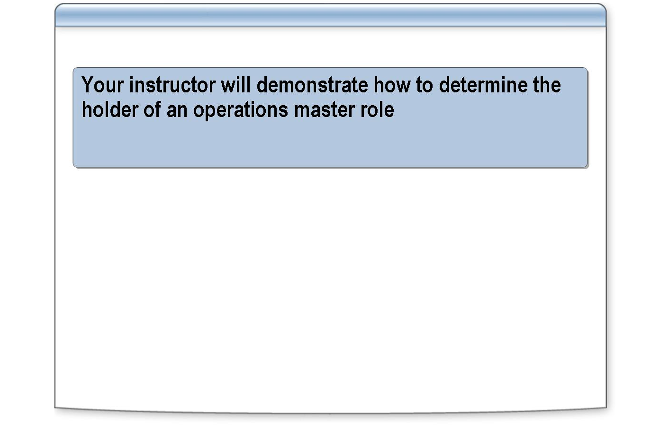
*****************************illegal for non-trainer use******************************
Before you consider moving an operations master role, determine which domain controller holds a particular operations master role. Only authenticated users have the permission to determine where the operations master roles are located. Depending on the operations master role, use one of the following Active Directory snap-ins:
Introduction
- Active Directory Users and Computers (PDC, RID, and infrastructure master roles)
- Active Directory Domains and Trusts (domain naming master role)
- Active Directory Schema (schema master role)

To determine which domain controller holds the RID master role, PDC emulator role, or infrastructure master role, perform the following steps.
Procedure for determining the RID master, the PDC emulator, and the infrastructure master
    - Open Active Directory Users and Computers.
    - In the console tree, right-click the domain for which you want to view operations masters, and then click Operations Masters.
    - On the RID, PDC, or Infrastructure tabs, under Operations master, view the name of the current operations master.

To determine which domain controller holds the domain naming master role, perform the following steps:
Procedure for determining the domain naming master
    - Open Active Directory Domains and Trusts.
    - Right-click Active Directory Domains and Trusts, and then click Operations Master.
    - In the Change Operations Master dialog box, view the name of the current domain naming master.

To determine which domain controller holds the schema master role, perform the following steps:

Procedure for determining the schema master
    - Register the Active Directory Schema snap-in by running the following command:
regsvr32.exe %systemroot%\system32\schmmgmt.dll
    - Click OK.
    - Create a custom Microsoft Management Console (MMC) console, and then add the Active Directory Schema snap-in to the console.
    - In the console tree, expand and right-click Active Directory Schema, and then click Operations Master.
    - In the Change Schema Master dialog box, view the name of the current schema master.

To identify an operations master in a different domain, connect to the domain before you click Operations Masters in step 4. To identify the operations master in a different forest, connect to the domain by typing the domain name of the forest before you click Operations Masters.
Note

How to Transfer an Operations Master Role

INCLUDEPICTURE "../Modules/PowerPnt/2279B_09/Slide_452.jpg" \* MERGEFORMATINET 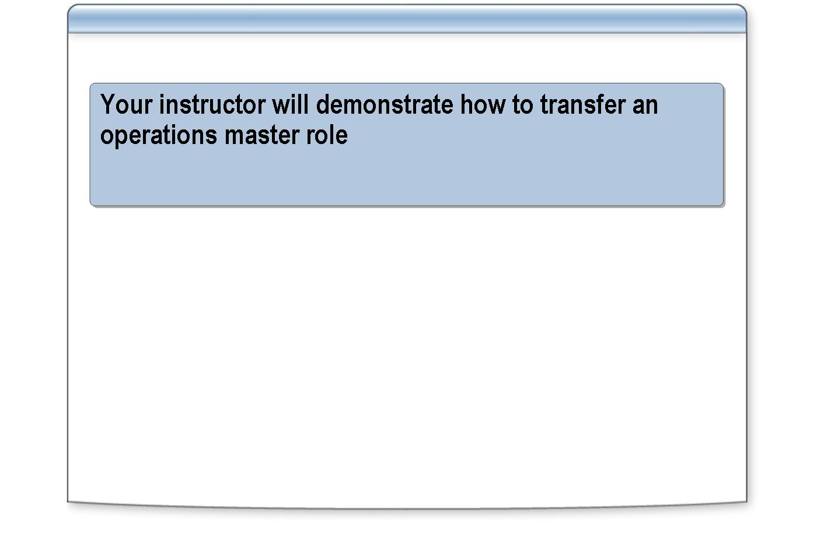
*****************************illegal for non-trainer use******************************
You can transfer the three domain-wide operations master roles by using Active Directory Users and Computers. To transfer the domain naming master role, use Active Directory Domains and Trusts. To transfer the Active Directory schema master role, use the Active Directory Schema tool.
Introduction
To transfer the operations master role for the RID master, PDC emulator, or infrastructure master, perform the following steps:
Procedure for transferring the RID master, PDC emulator, and infrastructure master roles
    - Open Active Directory Users and Computers.
    - In the console tree, right-click Active Directory Users and Computers, and then click Connect to Domain Controller.
    - In the Or select an available domain controller list, click the domain controller that will become the new operations master, and then click OK.
    - In the console tree, right-click the domain that contains the server that will become the new operations master, and then click Operations Masters.
    - On the Infrastructure, PDC, or RID tab, click Change, and then click Yes.

Ensure that you do not transfer the infrastructure master role to a domain controller that hosts the global catalog.
Caution

To transfer the domain naming master role to another domain controller, perform the following steps:

Procedure for transferring the domain naming master role
    - Open Active Directory Domains and Trusts.
    - In the console tree, right-click Active Directory Domains and Trusts, and then click Connect to Domain Controller.
    - In the Or select an available domain controller list, click the domain controller that will become the new domain naming master, and then click OK.
    - In the console tree, right-click Active Directory Domains and Trusts, and then click Operations Master.
    - When the name of the domain controller that you selected in step 3 appears, click Change, and then click Yes.

To transfer the schema operations master role, perform the following steps:
Procedure for transferring the schema master role
    - Open Active Directory Schema.
    - In the console tree, right-click Active Directory Schema, and then click Change Domain Controller.
    - Click Specify Name, type the name of the domain controller that you want to transfer the schema master role to, and then click OK.
    - In the console tree, right-click Active Directory Schema, and then click Operations Master.
    - When the name of the domain controller that you typed in step 3 appears, click Change, and then click Yes.

Before you open the Active Directory Schema, you must first use Regsvr32.exe to register the Active Directory Schema snap-in, Schmmgmt.dll, and then create a new custom MMC console.
Note

How to Seize an Operations Master Role

INCLUDEPICTURE "../Modules/PowerPnt/2279B_09/Slide_453.jpg" \* MERGEFORMATINET 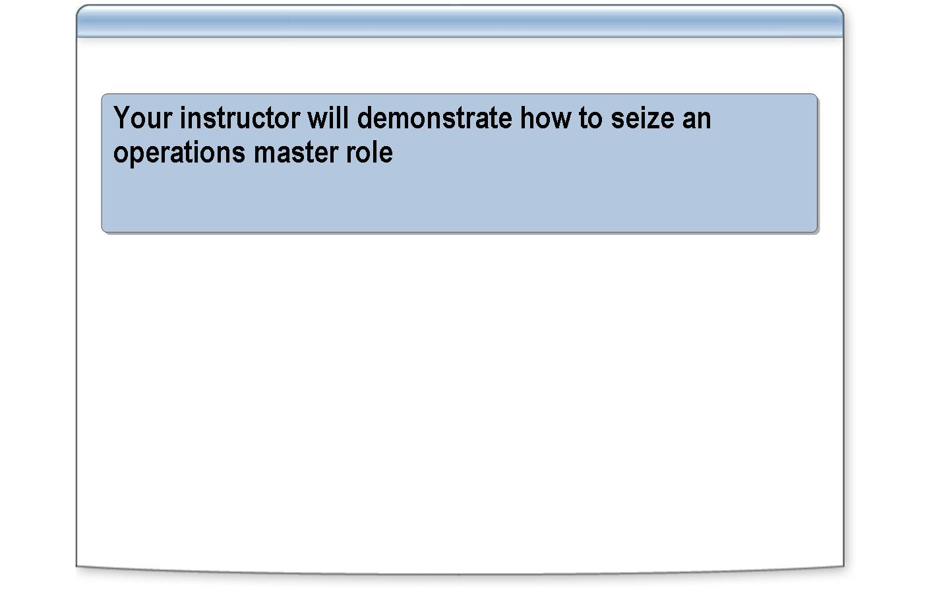
*****************************illegal for non-trainer use******************************
You can seize an operations master role by using the Ntdsutil command-line tool. The procedure varies slightly depending on the role that you seize. Because you can seize the PDC emulator and the infrastructure master roles without losing data, you can seize them by using Active Directory Users and Computers. To seize the other roles, use only the Ntdsutil utility to help prevent accidental seizing of these roles.
Introduction
To recover from a failure of a RID master, schema master, or domain naming master, perform the following tasks:
Recovery tasks
    - Disconnect the current operations master from the network before you seize the role.
    - To perform the seizure, use the ntdsutil command.
    - Wait until all updates that the failed domain controller made have been replicated to the domain controller that is seizing the role.
    - Ensure that the domain controller whose role was seized is removed from the domain and never restored.
    - Before you reconnect that computer to the network, reformat the partition that contained the operating system files of the original operations master and reinstall Windows Server 2003.

To seize an operations master role for the PDC emulator or infrastructure master, perform the following steps:

Procedure for seizing a role by using Active Directory Users and Computers
    - Open Active Directory Users and Computers.
    - In the console tree, right-click the domain for which you want to seize an operations master role, and then click Operations Masters.
It may take several seconds for the data to appear because Active Directory Users and Computers is waiting for a response from the current holder of the operations master role.
    - In the Operations Master dialog box, on the Infrastructure, PDC, or RID tab click Change.
    - In the Active Directory dialog box, click Yes.
    - When an Active Directory dialog box appears, indicating that this computer is a nonreplication partner, click Yes.
    - When an Active Directory dialog box appears, indicating a transfer is not possible, click Yes.
    - In the Active Directory dialog box, click OK, and then click Close.
    - Close Active Directory Users and Computers.

To use the ntdsutil command to seize an operations master role, perform the following steps:
Procedure for seizing a role by using Ntdsutil
    - In the Run box, type cmd and then click OK.
    - At the command prompt, type ntdsutil and then press ENTER.
    - At the ntdsutil prompt, type roles and then press ENTER.
    - At the fsmo maintenance prompt, type connections and then press ENTER.
    - At the server connections prompt, type connect to server followed by the fully qualified domain name (FQDN) of the domain controller that will be the new role holder, and then press ENTER.
    - Type quit and then press ENTER.
    - At the fsmo maintenance prompt, type one of the following commands to seize the appropriate operations master, press ENTER, type quit and then press ENTER.
  - Seize RID master
  - Seize PDC
  - Seize infrastructure master
  - Seize domain naming master
  - Seize schema master
    - At the ntdsutil prompt, type quit and then press ENTER.

Practice: Transferring Operations Master Roles

INCLUDEPICTURE "../Modules/PowerPnt/2279B_09/Slide_449.jpg" \* MERGEFORMATINET 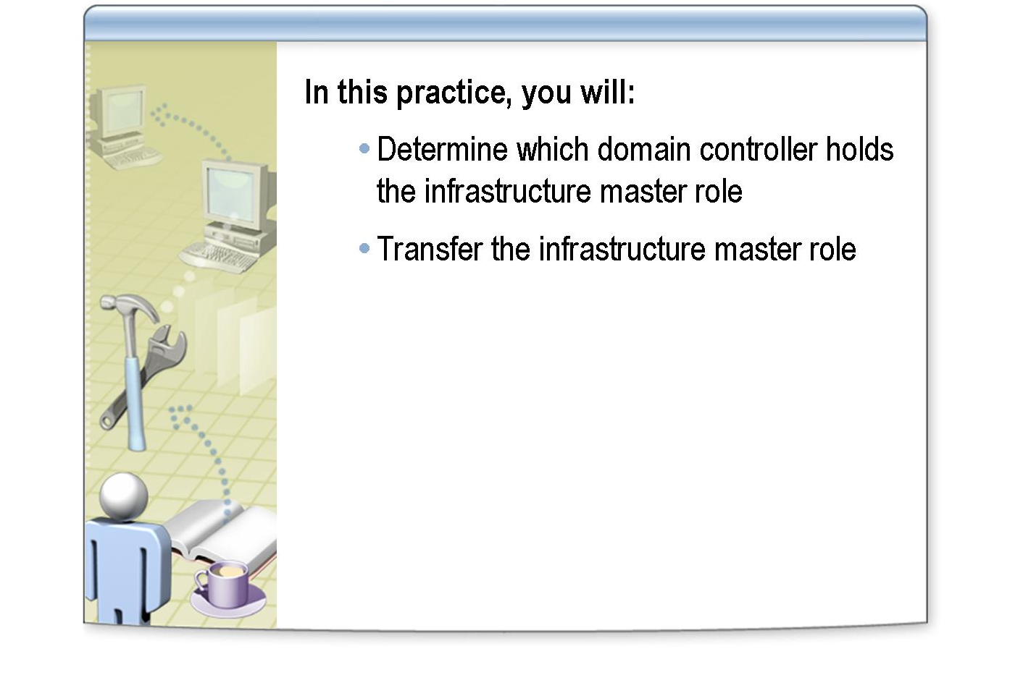
*****************************illegal for non-trainer use******************************
In this practice, you will:
Objectives
- Determine which domain controller holds the infrastructure master role in your domain.
- Transfer the infrastructure master role to the other server in the domain.

Work with a partner whose domain controller is in the same Active Directory domain as yours. This practice can only be performed on one server in the domain, so you must work together on a server.
Instructions
Northwind Traders is developing a disaster recovery plan. One important consideration is how the operations master roles will be distributed. The Active Directory implementation team has decided that they will place the infrastructure master role on a different server than the one that currently holds the role.
Scenario
- Transfer the infrastructure master role

Practice
    - Log on as Nwtradersx\ComputerNameUser with a password of P@ssw0rd
    - Click Start, point to Administrative Tools, right-click Active Directory Users and Computers, and then click Run as.
    - In the Run As dialog box, click The following user, type Nwtradersx\Administrator as the user name with a password of P@ssw0rd and then click OK.
    - In the console tree, right-click nwtradersx.msft, and then click Operations Masters.
    - On the Infrastructure tab, in the Operations master box, record the name of the current operations master, and then click Close.

    - In the console tree, right-click nwtradersx.msft, and then click Connect to Domain Controller.
    - In the Connect to Domain Controller dialog box, in the Or select an available domain controller list, select the server that does not currently host the infrastructure master role, and then click OK.
    - In the console tree, right-click nwtradersx.msft, and then click Operations Masters.
    - On the Infrastructure tab, click Change.
    - In the Active Directory dialog box, click Yes, and then click OK.
    - In the Operations Masters dialog box, notice that the operations master has been transferred to the selected domain controller, and then click Close.
    - Close Active Directory Users and Computers.

Lesson: Planning the Placement of Operations Masters

INCLUDEPICTURE "../Modules/PowerPnt/2279B_09/Slide_433.jpg" \* MERGEFORMATINET 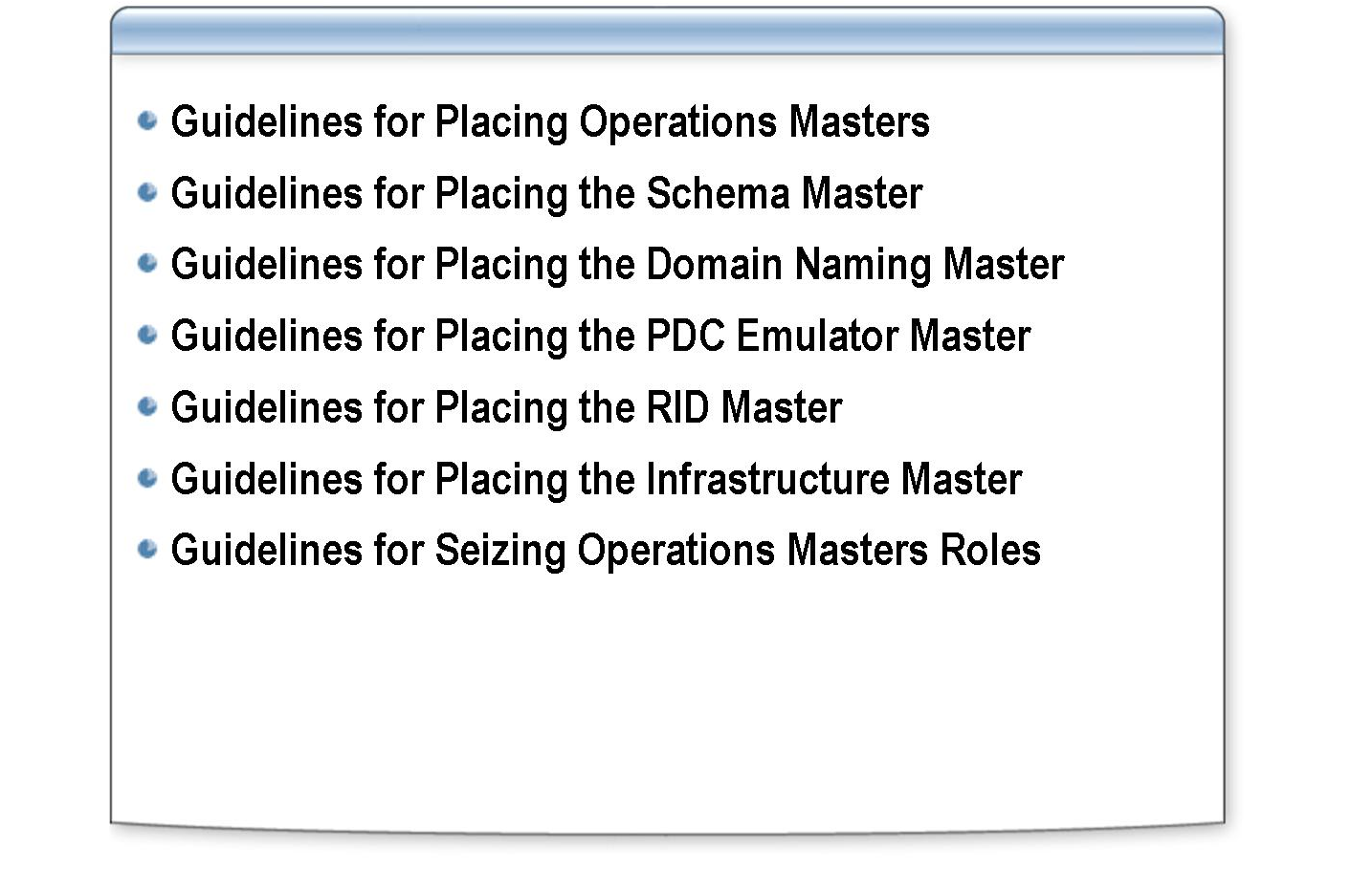
*****************************illegal for non-trainer use******************************
This lesson explains the guidelines for placing and seizing operations master roles.
Introduction
After completing this lesson, you will be able to:
Lesson objectives
- Explain guidelines for placing operations masters.
- Explain guidelines for placing the schema master.
- Explain guidelines for placing the domain naming master.
- Explain guidelines for placing the PDC emulator master.
- Explain guidelines for placing the RID master.
- Explain guidelines for placing the infrastructure master.
- Explain guidelines for seizing operations master roles.

Guidelines for Placing Operations Masters

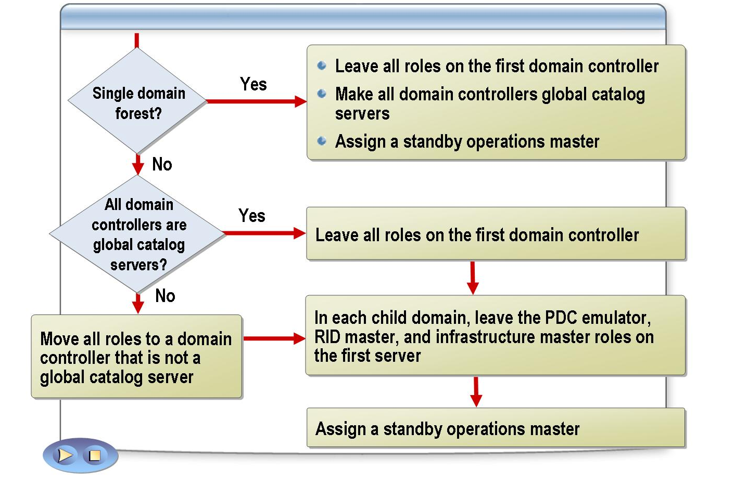
*****************************illegal for non-trainer use******************************
Windows Server 2003 automatically places operations master roles on domain controllers. This placement works well for a forest that is deployed on a few domain controllers in one site. In a forest that has many domain controllers or multiple sites, however, you must plan the placement of operations master roles to maximize performance and minimize risk in the event of a loss of the domain controller.
Introduction
Apply the following guidelines for placing operations masters:
Guidelines
- In a single domain forest, leave all of the operations master roles on the first domain controller in the forest. Designate each domain controller as a global catalog server, because the data in the global catalog contains only the domain data.
- In a multiple domain forest, use the following guidelines:
  - In the forest root domain:
    - If all domain controllers are also global catalog servers, leave all of the roles on the first domain controller in the forest.
    - If all domain controllers are not also global catalog servers, move all of the operations masters to a domain controller that is not a global catalog server.
  - In each child domain, leave the PDC emulator, RID master, and infrastructure master roles on the first server in the domain, and ensure that this server is never designated as a global catalog server.
- In each server that holds one or more operations master roles, make another domain controller in the same domain available as a standby operations master. The standby operations master should:

  - Not be a global catalog server except in a single domain environment, where all domain controllers are also global catalog servers.
  - Have a manually created replication connection to the domain controller that it is the standby operations master for, and it should be in the same site.

Guidelines for Placing the Schema Master

INCLUDEPICTURE "../Modules/PowerPnt/2279B_09/Slide_439.jpg" \* MERGEFORMATINET 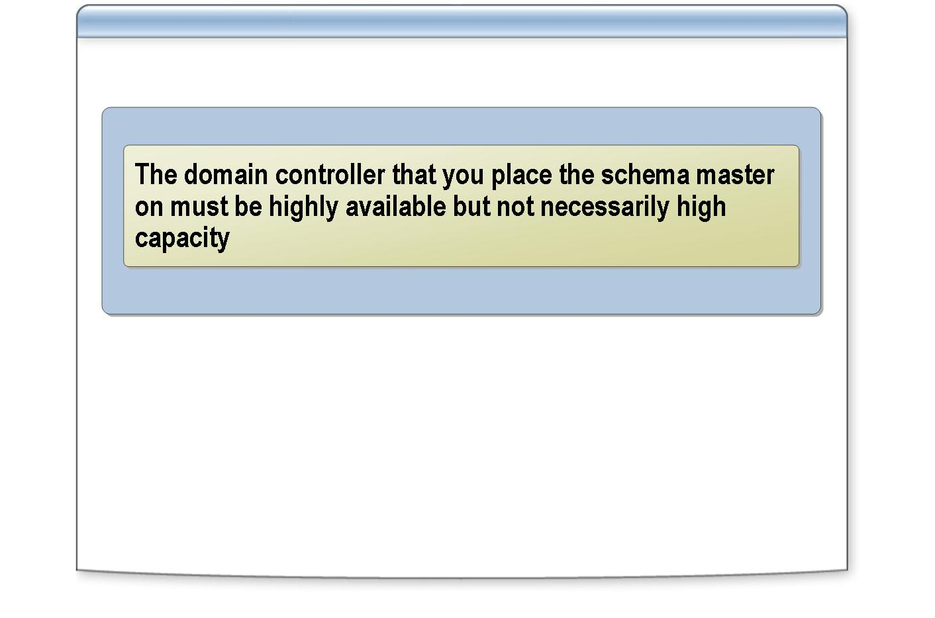
*****************************illegal for non-trainer use******************************
The schema master is a forest-wide operations master role. It controls all originating updates to the schema. If the schema master is unavailable, you cannot modify the schema. By default, the first domain controller of a new forest holds the schema master role.
Introduction
Apply the following guidelines to determine the placement of the schema master:
Guidelines
- Make a highly available domain controller the schema master. Because the schema defines all of the objects that Active Directory can store, it is critical for Active Directory to record all changes that are made to the schema.
A highly available domain controller is one that uses computer hardware that enables the domain controller to remain operational even during a hardware failure. For example, having a redundant array of independent disks (RAID) may enable the domain controller to keep running if one hard disk fails.
- Do not require that the schema master be a high-capacity domain controller. This requirement is unnecessary because schema changes are infrequent, the average server load is minimal, and the average replication traffic is not an overall concern.
A high-capacity domain controller is one that has comparatively higher processing power than other domain controllers to accommodate the additional work load of holding the operations master role. It has a faster CPU and possibly additional memory and network bandwidth.

Guidelines for Placing the Domain Naming Master

INCLUDEPICTURE "../Modules/PowerPnt/2279B_09/Slide_437.jpg" \* MERGEFORMATINET 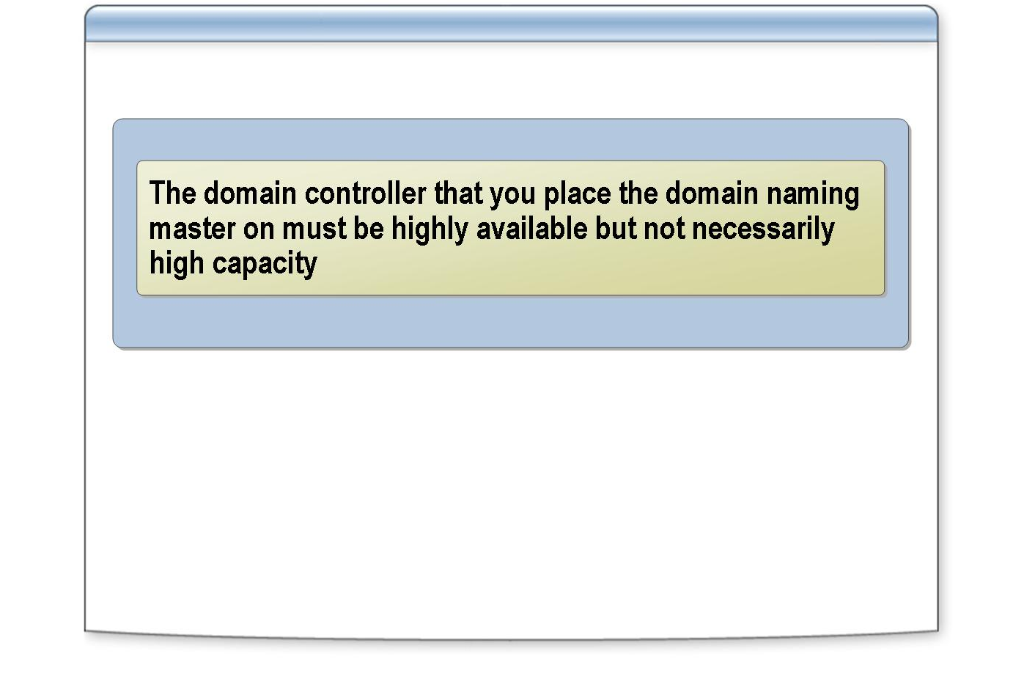
*****************************illegal for non-trainer use******************************
The domain naming master is a forest-wide operations master role. It controls the addition or removal of domains in the forest. By default, the first domain controller of a new forest holds the domain naming master role.
Introduction
Apply the following guidelines to determine the placement of the domain-naming master:
Guidelines
- Use a highly available domain controller as the domain naming master. High availability is necessary when you add or remove a domain to or from the forest.
- Do not require that the domain naming master be a high-capacity domain controller. Adding and removing domains are infrequent tasks and the average server load is minimal.

If the forest is set to a functional level of Windows 2000 native, you must locate the domain naming master on a server that hosts the global catalog. If the forest is set to a functional level of Windows Server 2003, it is not necessary for the domain naming master to be on a global catalog server.
Note

Guidelines for Placing the PDC Emulator Master

INCLUDEPICTURE "../Modules/PowerPnt/2279B_09/Slide_436.jpg" \* MERGEFORMATINET 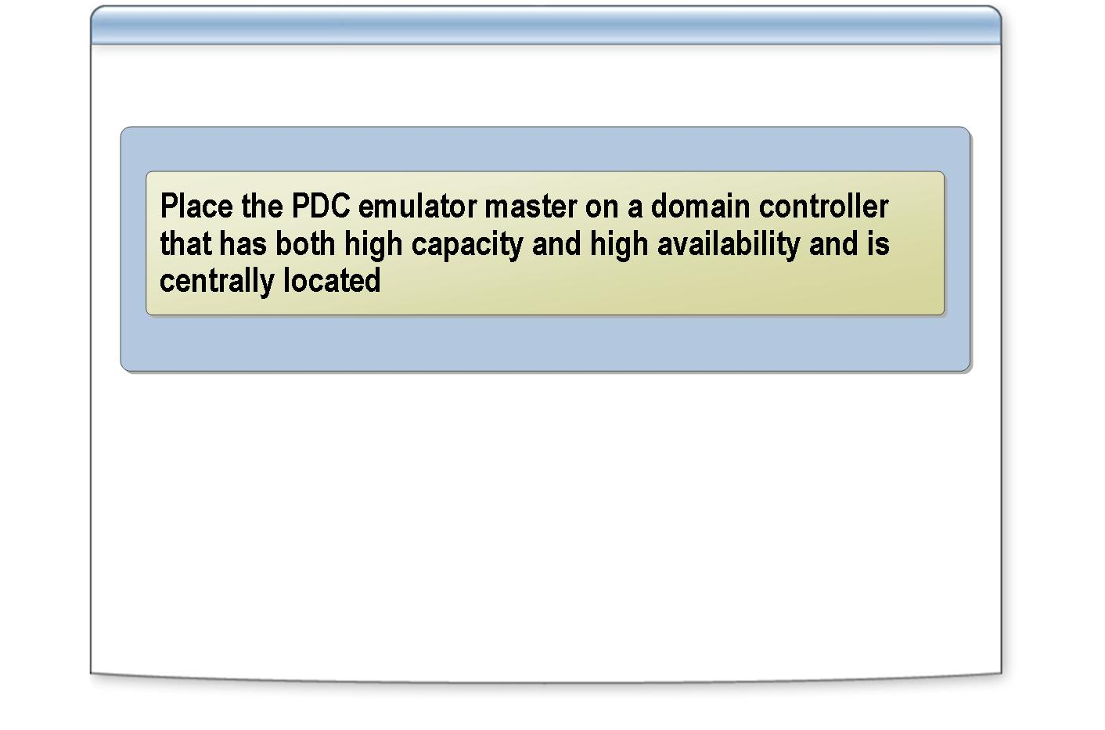
*****************************illegal for non-trainer use******************************
The PDC emulator master is a domain-wide operations master role. It acts as a PDC in Windows NT to support any backup domain controllers (BDCs) running Windows NT in a domain that is set to the Windows 2000 mixed or Windows interim domain functionality. The first domain controller that you create in a new domain is assigned the PDC emulator role.
Introduction
Apply the following guidelines to determine the placement of the PDC emulator master:
Guidelines
- Use a highly available domain controller as the PDC emulator. All domain controllers frequently access the PDC emulator for password changes, forwarding of mismatched passwords during logon, time synchronization, and support of BDCs and clients running Windows NT and earlier.
- Use a high-capacity domain controller as the PDC emulator. Because there is an increased load placed on this domain controller, do one of the following:
  - Increase the size of the domain controller’s processing power.
  - Do not make the domain controller a global catalog server.
  - Reduce the priority and the weight of the service (SRV) record to give preference for authentication to other domain controllers in the site.
- Do not require that the standby domain controller be a direct replication partner. Seizing the PDC emulator role does not result in lost data, so there is no need to reduce replication latency for a seize operation.

- Centrally locate this domain controller to accommodate the majority of the domain users. Centrally locating this domain controller will reduce the amount of network traffic.

For more information about how to place the PDC emulator master and reduce the workload on the PDC emulator, see “Guidelines for Placing the PDC Emulator Master” in Module 9 on the Appendices page on the Student Materials compact disc.
Note

Guidelines for Placing the RID Master

INCLUDEPICTURE "../Modules/PowerPnt/2279B_09/Slide_435.jpg" \* MERGEFORMATINET 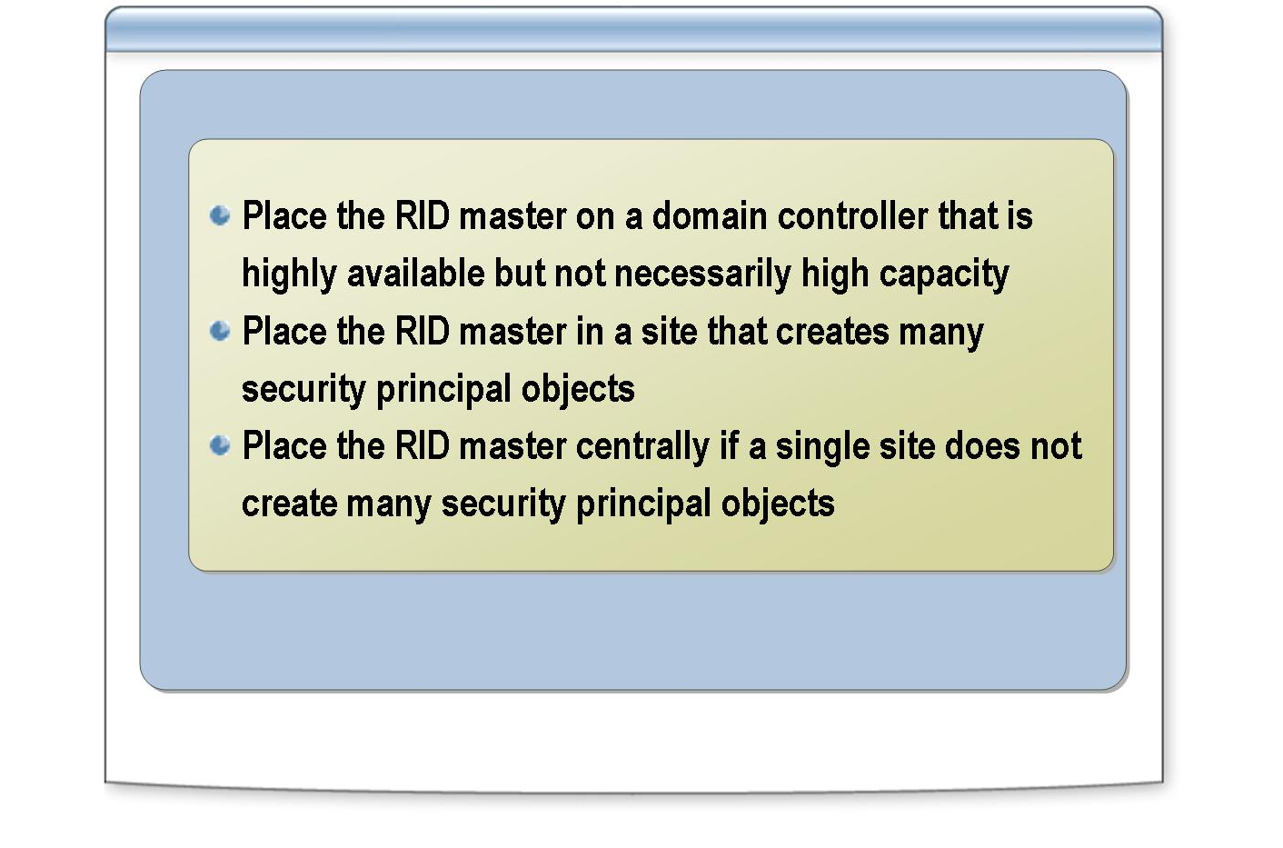
*****************************illegal for non-trainer use******************************
The RID master allocates blocks of RIDs to each domain controller in the domain. Whenever a domain controller creates a new security principal, such as a user, group, or computer object, the domain controller assigns the object a unique SID. There is only one RID master in each domain.
Introduction
Apply the following guidelines to determine the placement of the RID master:
Guidelines
- Use a highly available domain controller as the RID master. High availability is critical to the continued creation of security principals and to help prevent the necessity for seizing an operations master role.
- Do not require that the RID master be a high-capacity domain controller. Typically, you create security principals on an ongoing basis, which does not cause large peaks of CPU usage. Also, because RIDs are distributed in blocks of 500 to each domain controller, the average server load and the replication traffic are minimal.
- Place the RID master in a site where you create a large number of security principal objects, such as user and group objects. This placement is common when one group of administrators creates all user accounts for the organization because most of the user accounts are in the same location as the users, which reduces the potential effects of a network link failure.
- Locate the RID master centrally in your network if most of the user accounts are not created in one site. Placing the RID master centrally will reduce the amount of network traffic.
- Configure the RID master as a direct replication partner with the standby or backup RID master. This configuration reduces the risk of losing data when you seize the role because it minimizes replication latency.

Guidelines for Placing the Infrastructure Master

INCLUDEPICTURE "../Modules/PowerPnt/2279B_09/Slide_438.jpg" \* MERGEFORMATINET 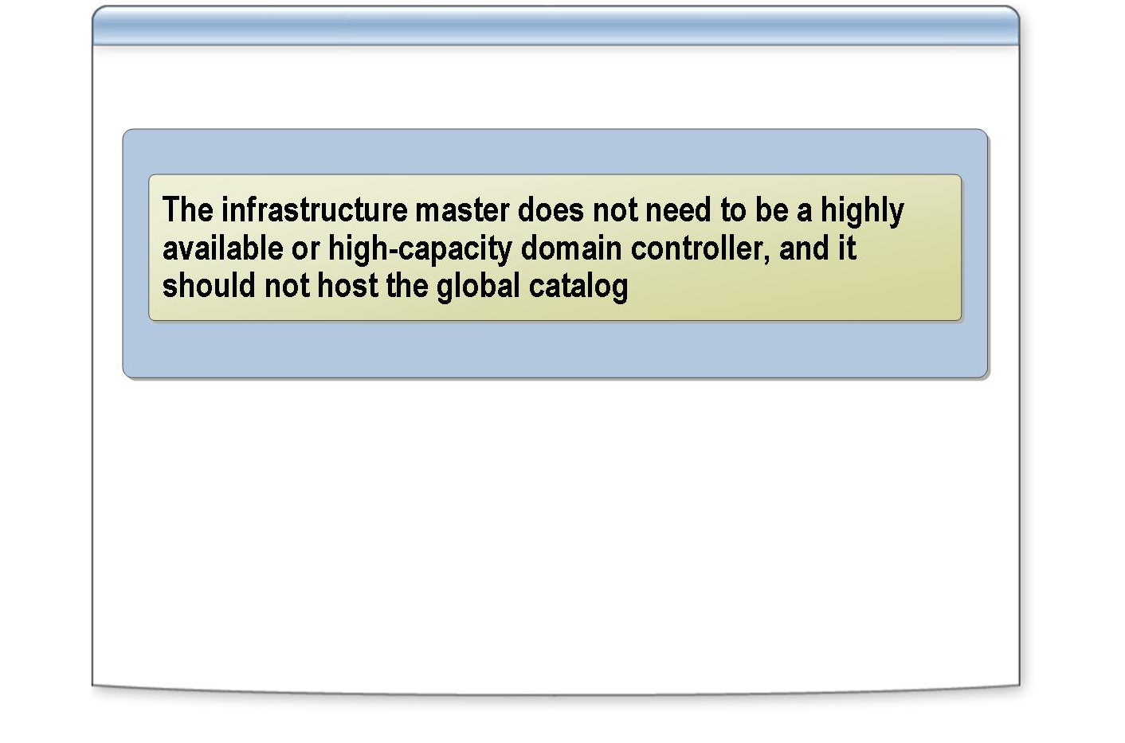
*****************************illegal for non-trainer use******************************
The infrastructure master is responsible for making fast updates of cross-domain references, such as membership changes in a group that contains user accounts from other domains. There is only one infrastructure master in a domain.
Introduction
Apply the following guidelines to determine the placement of the infrastructure master:
Guidelines
- Do not require that the infrastructure master be a highly available domain controller. There is no potential loss of information controlled by this operations master. In addition, the impact of the infrastructure master being offline for a short period of time is negligible because it does not affect end users.
- Do not require that the infrastructure master be a high-capacity domain controller. The infrastructure master does not use server resources intensively.
- Avoid placing the infrastructure master role on a domain controller that hosts a global catalog. If a domain controller that holds the infrastructure master role is also a global catalog server, cross-domain object references in that domain are not updated.
- Locate the infrastructure master in the same site as a global catalog server. The infrastructure master must communicate with a global catalog server to update its cross-domain references.

Guidelines for Seizing Operations Masters Roles

INCLUDEPICTURE "../Modules/PowerPnt/2279B_09/Slide_448.jpg" \* MERGEFORMATINET 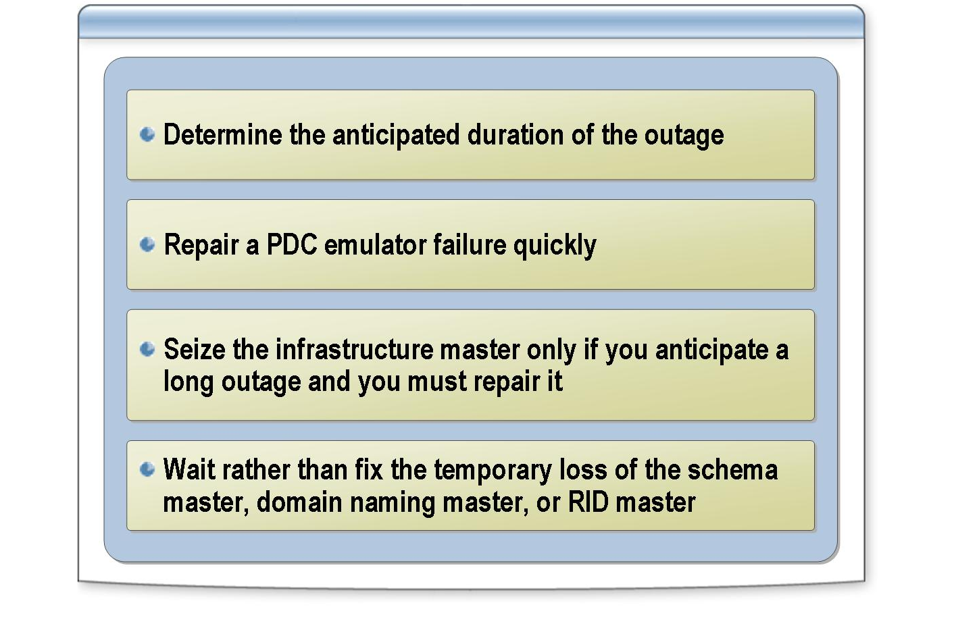
*****************************illegal for non-trainer use******************************
Only seize operations master roles when you cannot restore the domain controller that supports the role—for example, when a domain controller is physically destroyed and cannot be restored from backup media. Before seizing an operations master role, physically disconnect the domain controller from the network.
Introduction
Apply the following guideline to respond to operations master failures:
Guidelines
- Determine the anticipated duration of the outage. If you expect the outage to be brief, wait for the role owner to become available before you perform a role-related function. If the outage is longer, it may be necessary to seize the operations master role from a domain controller. This decision depends on the role and the expected length of the outage.

Apply the following guideline to seize a PDC emulator master:
- Repair a PDC emulator failure quickly. A user running Windows NT Workstation, Windows NT 4.0, Windows 95, or Windows 98 without the Active Directory client cannot change her password without her computer communicating with the PDC emulator. If her password has expired, she cannot log on. Seize the PDC emulator role from a standby operations master domain controller if the PDC emulator is offline for a significant period of time.

Apply the following guideline to seize an infrastructure master:
- Wait rather than fix a temporary loss of the infrastructure master. The temporary loss is not visible to end users or administrators, unless you recently moved or renamed a large number of accounts. Seize the infrastructure master role if you anticipate a long outage and you must repair it.

Apply the following guidelines for seizing the schema, RID, and domain naming masters:

- Wait rather than fix the temporary loss of the schema master, domain naming master, or RID master. These roles are not visible to end users nor do they typically hinder your work as an administrator.
- Physically disconnect the domain controller from the network to ensure that its outage is permanent. A domain controller whose schema master, domain naming master, or RID master role is seized must never come back online.

Multimedia Practice: Planning the Placement of Operations Masters

INCLUDEPICTURE "../Modules/PowerPnt/2279B_09/Slide_441.jpg" \* MERGEFORMATINET 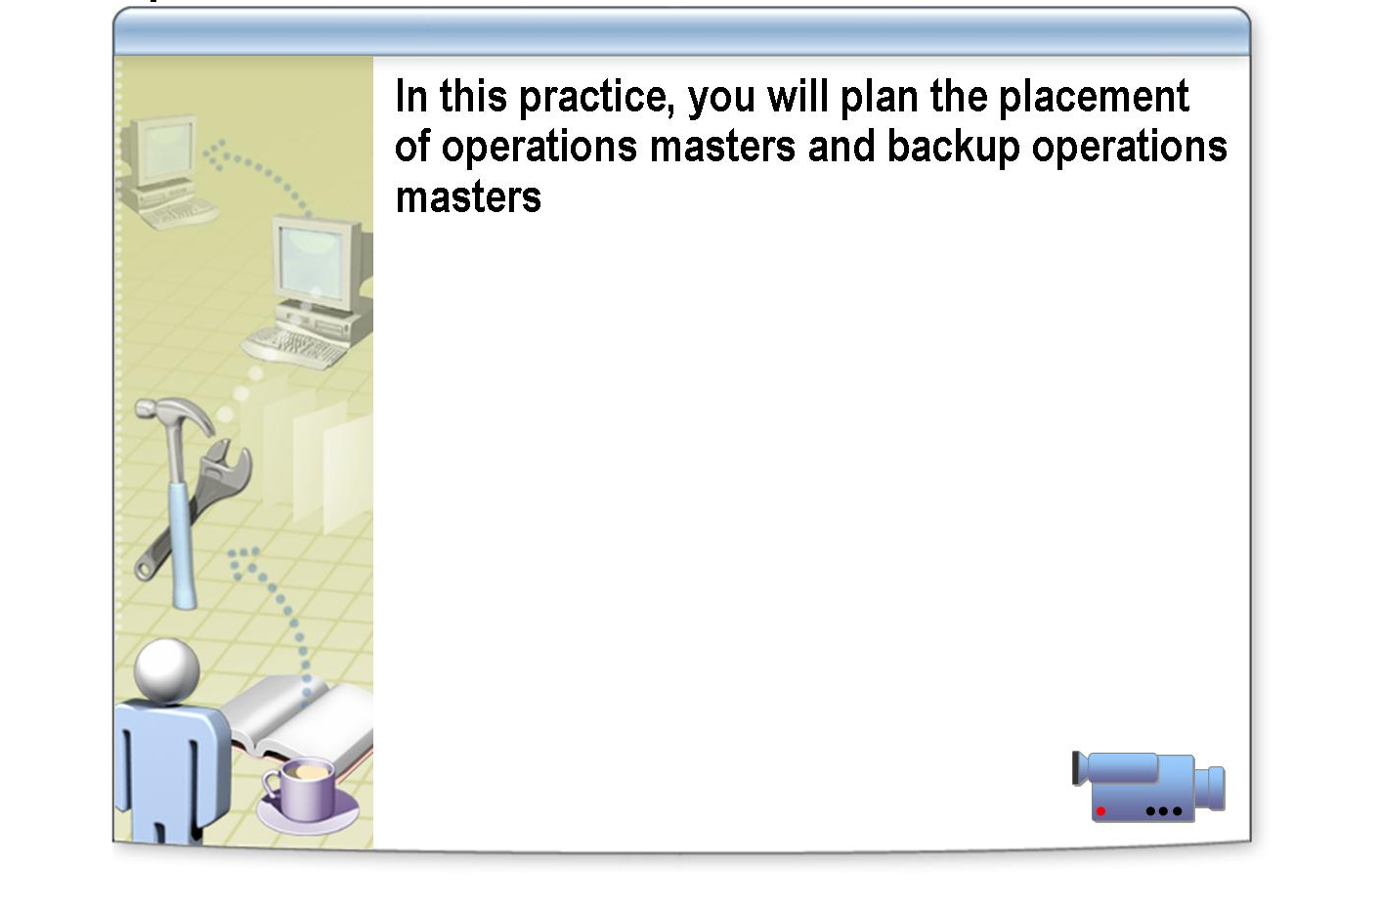
*****************************illegal for non-trainer use******************************
To view the Placing Operations Masters multimedia practice, open the Web page on the Student Materials compact disc, click Multimedia, and then click the title of the presentation. Do not open this presentation unless the instructor tells you to.
File location
In this practice, you will plan the placement of an operations master.
Objective
This activity includes multiple choice and drag-and-drop exercises that help you test your knowledge. Read the instructions, and then begin the practice.
Instructions

Lab A: Managing Operations Masters

INCLUDEPICTURE "../Modules/PowerPnt/2279B_09/Slide_327.jpg" \* MERGEFORMATINET 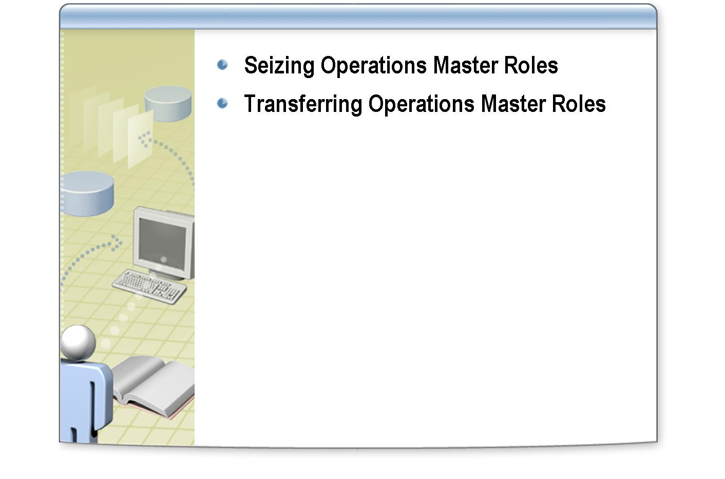
*****************************illegal for non-trainer use******************************
After completing this lab, you will be able to transfer and seize operations master roles in Active Directory.
Objectives
Before working on this lab, you must have knowledge of the purpose of each of the five operations master roles in Active Directory.
Prerequisites
You are the administrator who is responsible for managing single master operations roles for Northwind Traders. You will seize an operations master role, and then transfer operations master roles according to the plan for them that the Active Directory design team developed.
Scenario
Estimated time to complete this lab:
30 minutes
Exercise 1
Seizing Operations Master Roles

In this exercise, you will use Ntdsutil.exe to seize the infrastructure master role from your partner’s server. The domain controller that holds the infrastructure master role has experienced a power surge because of a malfunctioning uninterruptible power supply (UPS). The problem has been traced to a spilled beverage. The computer no longer functions.

Tasks | Special instructions
- Use Active Directory Users and Computers to determine which server in your domain holds the infrastructure master role. | Important: Perform this task on both servers in the domain.
Which server holds the infrastructure master role?

- To simulate a server failure, shut down the server in your domain that holds the infrastructure master role. | Important: Perform this task only on the server that holds the infrastructure master role.
- Use Ntdsutil.exe to seize the infrastructure master role. | - Log on as Nwtradersx\ComputerNameUser with a password of P@ssw0rd  - Click Start, right-click Command Prompt, and then click Run as.  - In the Run As dialog box, click The following user, type a user name of Nwtradersx\Administrator, a password of P@ssw0rd and then click OK.  Important: Perform this task only on the server that does not hold the infrastructure master role.
- Start the server that you shut down in step 2.

Exercise 2
Transferring Operations Master Roles

In this exercise, you will transfer operations master roles to another server. The Northwind Traders IT team has decided to place the PDC emulator and the RID master roles on a server that does not hold the schema master and domain naming master roles. You must transfer the PDC emulator and the RID master roles to the other server.

Tasks | Special instructions
- Transfer the PDC emulator role to the other server in your domain. | - Log on as Nwtradersx\ComputerNameUser with a password of P@ssw0rd  - Click Start, right-click Command Prompt, and then click Run as.  - In the Run As dialog box, click The following user, type a user name of Nwtradersx\Administrator, a password of P@ssw0rd and then click OK.  Important: Perform this task only on the server that currently holds the PDC emulator and RID master roles.
- Transfer the RID master role to your server. | - Log on as Nwtradersx\ComputerNameUser with a password of P@ssw0rd  - Click Start, right-click Command Prompt, and then click Run as.  - In the Run As dialog box, click The following user, type a user name of Nwtradersx\Administrator, a password of P@ssw0rd and then click OK.  Important: Perform this task only on the server that does not hold the RID master role.
- Use Active Directory Users and Computers to verify that the roles were transferred successfully. | Important: Perform this task on both servers in the domain.

Course Evaluation

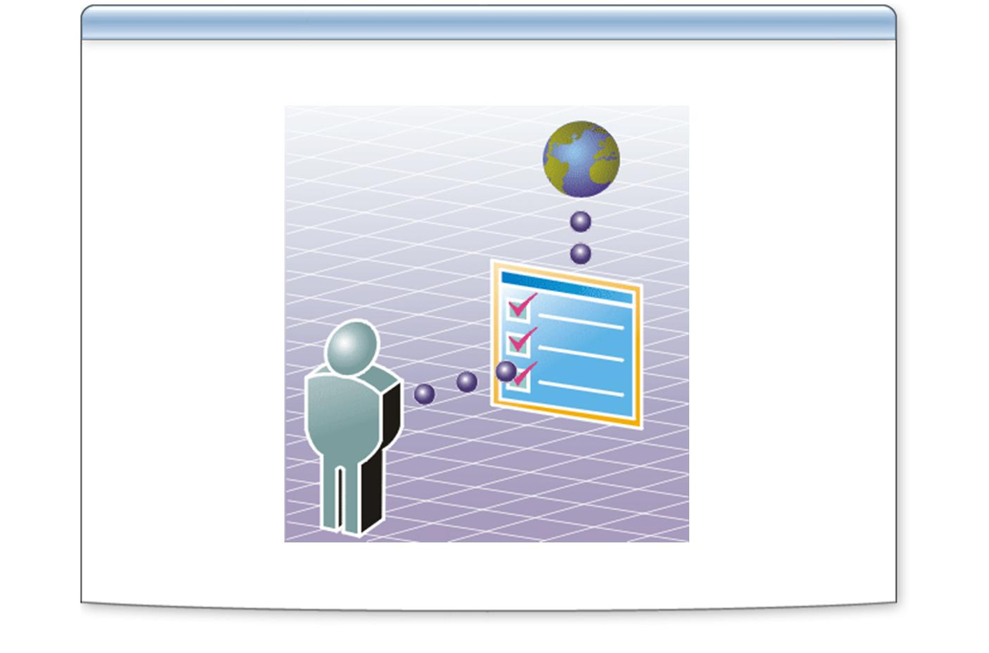
*****************************illegal for non-trainer use******************************
Your evaluation of this course will help Microsoft understand the quality of your learning experience.
At a convenient time before the end of the course, please complete a course evaluation, which is available at http://www.CourseSurvey.com.
Microsoft will keep your evaluation strictly confidential and will use your responses to improve your future learning experience.

